SIMATS ENGINEERING

ASSESSMENT TOOL 1

COURSECODE: CSA1603
COURSE NAME: Data Warehousing and Data Mining
NAME: M. FARAH AFRIN
REG.NO: 192511434

COURSE OUTCOME COVERED
CO5: Apply association rule mining techniques to discover interesting relationships and patterns within large datasets
Assessment Tool Weightage: 35%

QUESTIONS: 05 Total Marks:50

Annexure A
Constraint-Based Problem Solving

Criteria | Problem Understanding (2.5) | Constraint Analysis (2.5) | Solution Development (2.5) | Application of Concepts (1.5) | Justification  (1) | Total(10)
Weightage | 25% | 25% | 25% | 15% | 10% | 100%
Q1
Q2
Q3
Q4
Q5

Code of Conduct:
I M. FARAH AFRIN / 192511434_(Name / Reg No) certify that this submission is my original work and that I have adhered to the guidelines specified for this assessment.
I understand that any violation of academic integrity rules will result in disciplinary action.
Farah Afrin
Signature of the student:
RUBRICS FOR CALCULATION:

Constraint-Based Problem Solving Assessment Rubric
Criteria | Weightage | Level 4 (Exemplary) | Level 3 (Proficient) | Level 2 (Developing) | Level 1 (Beginning)
Problem Understanding | 25% | Clearly defines the problem and identifies all relevant constraints  accurately | Identifies most constraints with minor gaps | Partial understanding; misses key constraints | Fails to identify constraints correctly
Constraint Analysis | 25% | Analyzes constraints effectively and prioritizes  them logically | Provides reasonable analysis with some prioritization | Limited analysis; weak prioritization | No meaningful analysis or prioritization
Solution Development | 25% | Develops optimal and feasible solutions satisfying all  constraints | Develops workable solutions with minor limitations | Solutions partially satisfy constraints | Solutions do not meet constraints
Application of Concepts | 15% | Effectively applies appropriate concepts, methods, or  tools | Applies concepts with minor errors | Limited application; requires guidance | Unable to apply relevant concepts
Justification | 10% | Provides strong justification for decisions  with logical reasoning | Provides justification with some clarity | Weak or unclear justification | No justification provided

Annexure A

Constraint-Based Problem Solving (6 Marks) (BL4–BL5) – Reframed with New Scenarios
Q1. Dataset: Hospital Patient Records

PID Symptoms Observed
P1 Fever, Cough P2 Fever, Headache
P3 Cough, Headache
P4 Fever, Cough, Headache P5 Fever, Fatigue

Question:
Apply association rule mining with minimum support = 50% and confidence = 70%, under the constraint that all generated rules must include "Fever". Identify the valid association rules and justify why they satisfy the given constraints. (BL4 – 1.2 Marks)

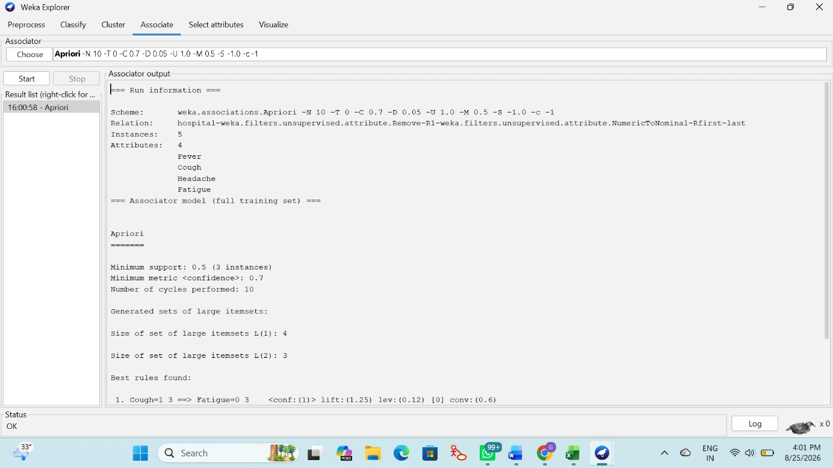


Q2. Dataset: Online Learning Platform

Student ID Courses Enrolled
S1 Python, SQL
S2 Python, Data Science
S3 SQL, Machine Learning
S4 Python, SQL, Data Science
S5 Python, Machine Learning

Question:
Using the dataset, generate frequent itemsets with minimum support = 40%, applying the constraint that each itemset must contain at least two courses. Explain how the constraint helps in pruning candidate itemsets during mining. (BL4 – 1.2 Marks)

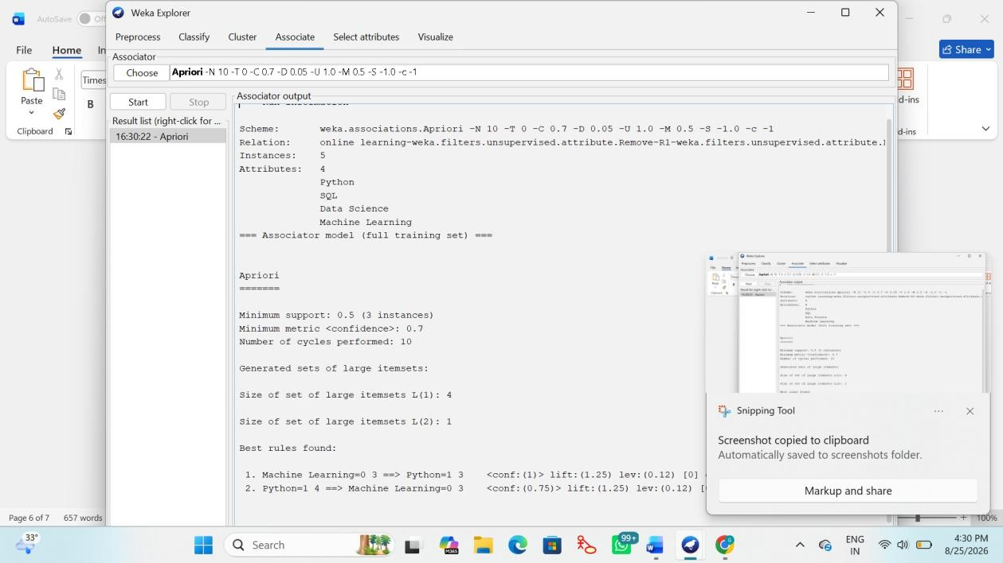

Q3. Dataset: Library Borrowing Records

Transaction ID Books Borrowed
T1 Data Mining, Python Programming
T2 Data Mining, Database Systems
T3 Python Programming, Database Systems
T4 Data Mining, Python Programming, Database Systems T5 Data Mining, Artificial Intelligence

Question:
Apply the Apriori algorithm with the constraint that the maximum itemset size is 3. Identify the frequent itemsets and explain how the constraint reduces computational complexity during candidate generation. (BL5 – 1.2 Marks)

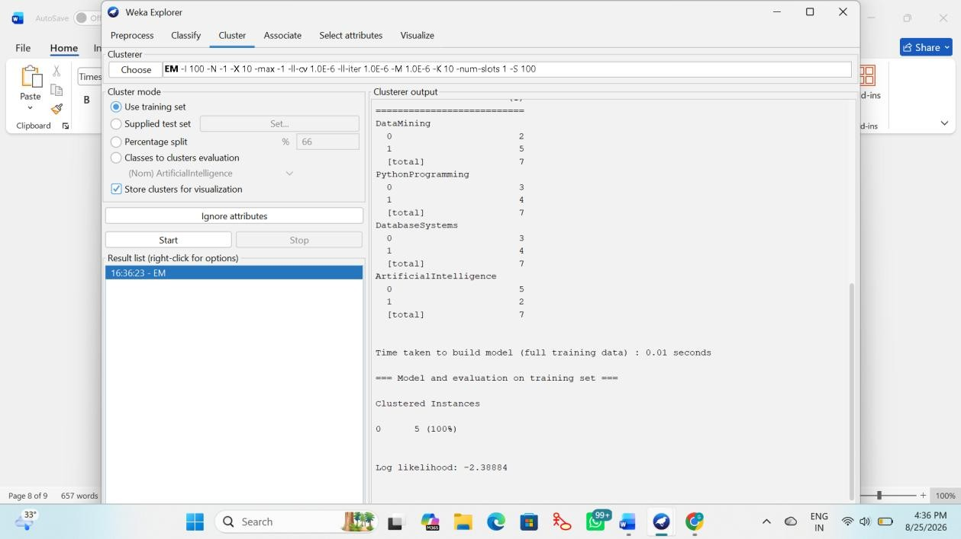
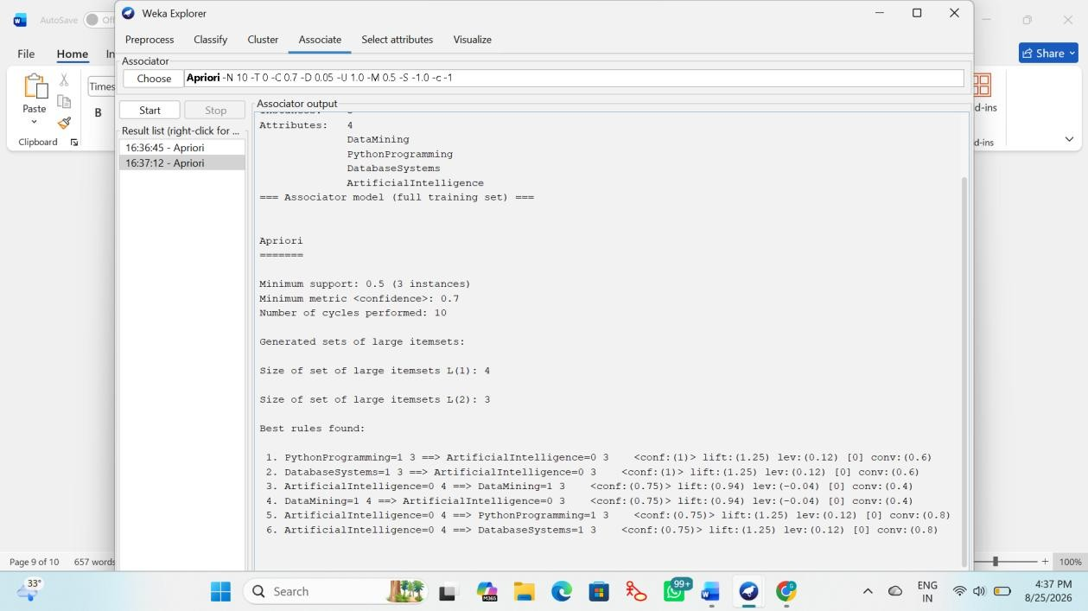

Q4. Dataset: University Course Hierarchy

Student ID Courses Taken
S1 Engineering, Computer Science, Machine Learning S2 Engineering, Information Technology
S3 Engineering, Computer Science
S4 Engineering, Computer Science, Machine Learning S5 Engineering, Information Technology

Question:
Apply multilevel association rule mining with the constraint that rules should be generated only at the "Computer Science" level. Explain how the course hierarchy affects the discovery of association rules. (BL5 – 1.2 Marks)

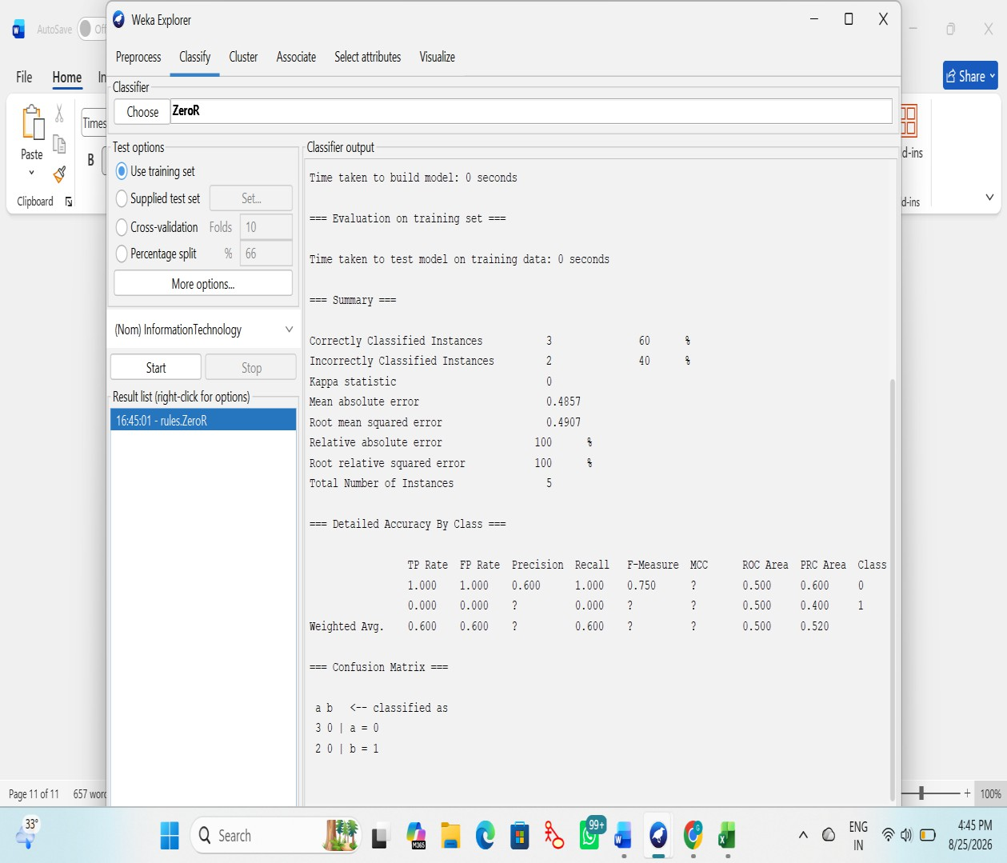
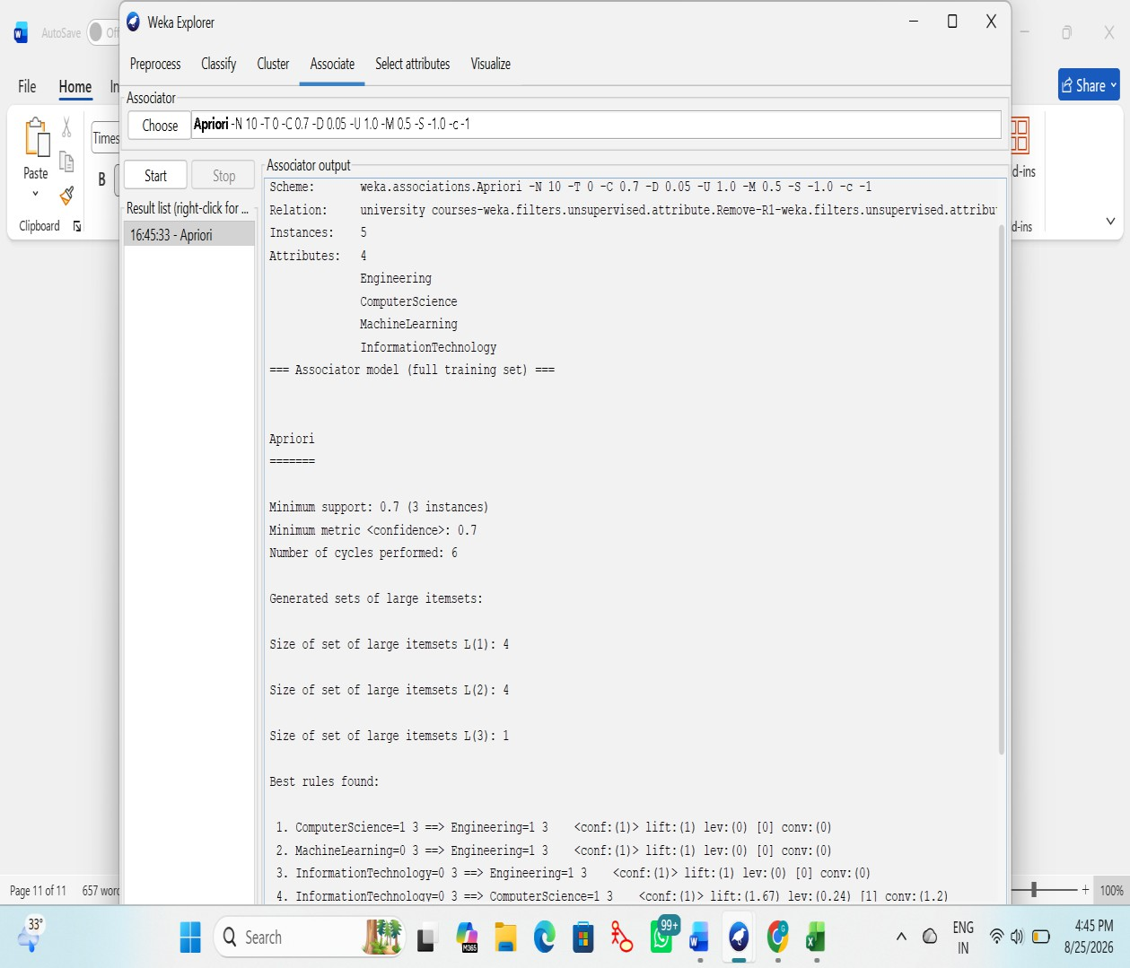

Q5. Dataset: Insurance Customer Records

CID Age Group Income Level Policy Purchased

C1 | Young | High | Health Insurance
C2 | Middle | Medium | Vehicle Insurance
C3 | Young | Low | Travel Insurance
C4 | Senior | High | Health Insurance
C5 | Young | Medium | Vehicle Insurance

Question:
Apply multidimensional association rule mining with the constraint Age Group = "Young". Identify meaningful patterns involving income level and policy type, and explain how these patterns can support targeted marketing strategies. (BL4 – 1.2 Marks)

